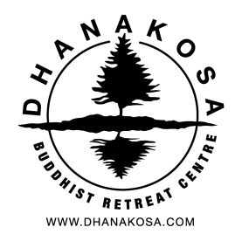
Dhanakosa: Volunteer Application Form
Date:

Personal details:
Name:
Address:
Postcode:
Home phone:
Mobile:
Email:

Please indicate your involvement with the Triratna Buddhist Community:
Little or no previous contact
Regular contact with local centre/ retreat centre
- if so which one?
Mitra
Asked for Ordination
Order member

Please indicate the area/s in which you would like to contribute:
 | I am interested in volunteering in these areas | I am willing to volunteer in these areas | I would rather not volunteer in these areas
Cooking
Gardening and grounds
Maintenance/DIY
Painting and decorating
Housekeeping

Skills and experience: Please give us some information regarding your experience/qualifications and any specific DIY/building skills e.g. plumbing, electrical, joinery etc:
Please see over
Do you have a current driving licence? | Yes/No
The role involves often working outside and undertaking heavier tasks. Please comment on your physical health and ability to undertake this kind of work:

We would like to find out a little more about you, for example,
- Why are you interested in becoming a volunteer in a Buddhist community?
- What do you hope to gain from the experience?
- Is there anything else we need to know about you, in terms of mental and physical health that may be relevant to your ability to relate to the community and your work?

Please use the space below to answer these questions, continuing on a separate sheet if necessary:
Please see over
Please provide contact details for two references. If possible at least one who is a member of the Triratna Buddhist Order.

Any information you give us will be treated as confidential and only discussed with members of the community where appropriate.

Many thanks for taking the time to complete this application form and for your interest in becoming a volunteer for Dhanakosa.

Please return the form by email to info@dhanakosa.com or by post to:

Dhanakosa,
Balquhidder,
Lochearnhead,
FK19 8PQ.

